**《语义网与知识图谱》实验手册**

**实验一 RDF（RDFS）应用**

目的：

1. 回顾了解XML、RDF语法；
2. 理解语义网资源描述语言；
3. 掌握RDF(S)的使用。

**1、在线学习XML和RDF教程**

<https://www.w3cschool.cn/xml/>

https://www.w3cschool.cn/rdf/

**2、练习**

**【习题1】** Consider the following RDF document:

<rdf:RDF

xmlns:rdf="http://www.w3.org/1999/02/22-rdf-syntax-ns#"

xmlns:rdfs="http://www.w3.org/2000/01/rdf-schema#"

xmlns:iswww="http://sw.edu/#"

>

<rdf:Description rdf:about="http://sw.edu/#germany">

<rdf:type rdf:resource="http://sw.edu/#country" />

</rdf:Description>

<rdf:Description rdf:about="http://sw.edu/#capital_of">

<rdf:type rdf:resource="http://www.w3.org/1999/02/22-rdf-syntax-ns#Property"/>

<rdfs:domain rdf:resource="http://sw.edu/#city" />

<rdfs:range rdf:resource="http://sw.edu/#country" />

</rdf:Description>

<rdf:Description rdf:about="http://sw.edu/#country">

<rdf:type rdf:resource="http://www.w3.org/2000/01/rdf-schema#Class" />

<rdfs:label xml:lang="de">Land</rdfs:label>

</rdf:Description>

<rdf:Description rdf:about="http://sw.edu/#berlin">

<rdfs:label xml:lang="en">Berlin</rdfs:label>

<rdf:type rdf:resource="http://sw.edu/#city" />

<iswww:capital_of rdf:resource="http://sw.edu/#germany" />

</rdf:Description>

<rdf:Description rdf:about="http://sw.edu/#city">

<rdf:type rdf:resource="http://www.w3.org/2000/01/rdf-schema#Class" />

<rdfs:label xml:lang="de">Stadt</rdfs:label>

</rdf:Description>

</rdf:RDF>

• Describe in natural language the content of this document.

|  |
| --- |
| - Germany是Country的一个实例；  - capital_of是Property_Of的一个实例，其定义域时city，值域是country；  - country是Class的一个实例，其德语表达是Land，rdfs:label中的lang标签“de”的语言为德语，可见图1    图1 常见语言ISO代码  - berlin的英语是Berlin，berlin是city的一个实例，berlin是germany的首都  - city是class的一个实例，其德语表达是Stadt |

• Draw the graph representation of the above document.\

|  |
| --- |
|  |

【习题2】Write down the modeled list authors of this book from following RDF graph in Turtle syntax.

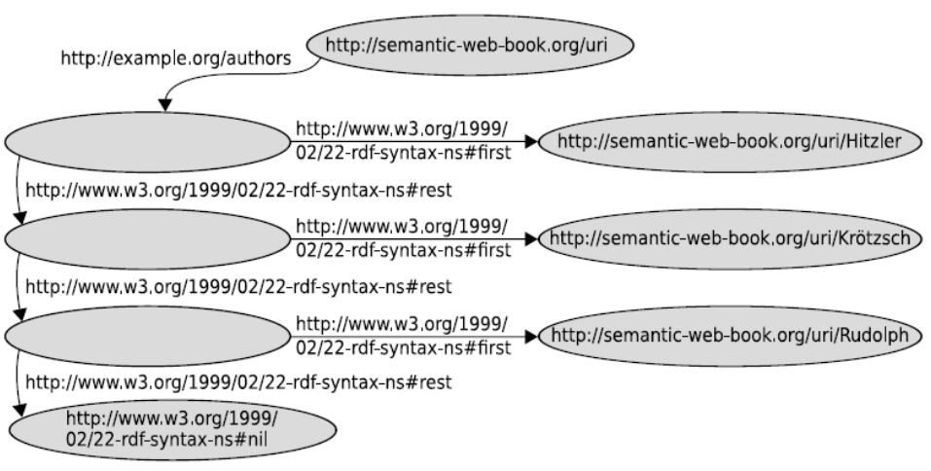

|  |
| --- |
| Hitzler  Krötzsch  Rudolph |

【习题3】 Write the following Turtle triple in RDF/XML syntax:

:Person rdfs:comment "Represents the set of all people."^^xsd:string .

|  |
| --- |
| <?xml version = “1.0”?>  <rdf:RDF  xmlns:rdf = “http://www.w3.org/1999/02/22-rdf-syntax-ns#”  xmlns:rdfs = “http://www.w3.org/2000/01/rdf-schema#”  >  <rdf:Description rdf:about = “http://Person”>  <rdfs:comment rdfs:Datatype = “http://www.w3.org/2000/01/rdf-schema#string”>  Represents the set of all people.  </rdfs:comment>  </rdf:Description>  </rdf:RDF> |

【习题4】 Represent the following sentences graphically by means of reified triples:

* Romeo thought that Juliet was dead.
* John believes that Mary wants to marry him.
* The dwarf noticed that somebody had been eating from his plate.

|  |
| --- |
| Romeo thought that Juliet was dead.    John believes that Mary wants to marry him.    The dwarf noticed that somebody had been eating from his plate. |